Key Vocabulary:

* response variable
* explanatory variable
* independent variable
* dependent variable
* scatterplot
* positive association
* negative association
* linear
* correlation
* r-value
* regression line
* mathematical model
* least-squares regression line
*  ”y-hat”
* SSM
* SSE
* r2
* coefficient of determination
* residuals
* residual plot
* influential observation

Calculator Skills:

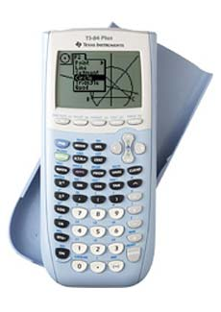

* seq(X,X,min,max,scl)
* 2-Var Stats
* sum
* Diagnostic On
* 
* Clear All Lists
* residual plot

**3.1 Scatterplots and Correlation**

1. What is the difference between a response variable and an explanatory variable?
2. How are response and explanatory variables related to dependent and independent variables?
3. When is it appropriate to use a scatterplot to display data?
4. Which variable always appears on the horizontal axis of a scatterplot?
5. You can describe the overall pattern of a scatterplot by the…
6. Explain the difference between a positive association and a negative association.
7. What does correlation measure?
8. What is true about the relationship between two variables if the r-value is:
9. Near 0?
10. Near 1?
11. Near -1?
12. Exactly 1?
13. Exactly -1?
14. Is correlation resistant to extreme observations? Explain.
15. What does it mean if two variables have high correlation?
16. What does it mean if two variables have weak correlation?
17. What does it mean if two variables have no correlation?
18. Explain why two variables must both be quantitative in order to find the correlation between them.
19. Does a correlation close to -1 or 1 always guarantee a linear relationship? Explain.

**3.2 Least-Squares Regression**

1. What is a regression line?
2. What is extrapolation and why is this dangerous?
3. What is a least-squares regression line?
4. What is the formula for the equation of the least-squares regression line? Define each variable.
5. The least-squares regression line always passes through the point...
6. What is a residual?
7. What special property do the residuals have? Why do they have this property?
8. What is a residual plot?
9. How can you calculate residuals on your calculator and use this to produce a residual plot?
10. If a least-squares regression line fits the data well, what characteristics should the residual plot exhibit?
11. What does the standard deviation of the residuals tell us?
12. How is the coefficient of determination defined?
13. If r2 = 0.95, what can be concluded about the relationship between x and y?
14. What are three limitations of correlation and regression?
15. Under what conditions does an outlier become an influential observation?
16. What is a lurking variable?
17. Why does association not imply causation?