**2.2 Normal Distributions**

Normal Distribution:

1. described by a Normal density curve which is symmetric, single-peaked, and bell-shaped.
2. Described by giving its mean  and standard deviation 
3. Normal distribution is abbreviated as N(,)

**The 68-95-99.7 Rule (Empirical Rule):**



**\*This rule applies ONLY for distributions that are approximately Normal**

**Example #9**

Suppose that the batting averages for the 432 MLB players in 2009 had a mean of0.261 with a standard deviation of 0.034. Suppose that the distribution is exactly Normal with and 

1. Sketch a Normal density curve for this distribution of batting averages. Label the points that are 1, 2, and 3 standard deviations from the mean
2. What percent of the batting averages are above 0.329?

c) What percent of the batting averages are between 0.193 and 0.295?

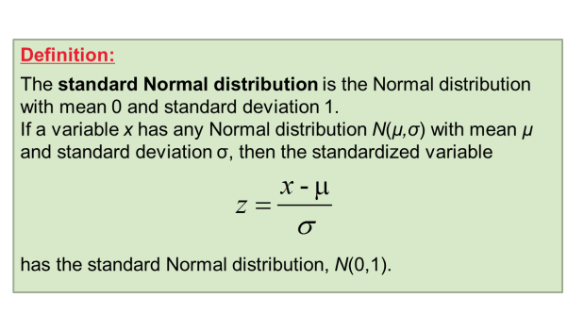

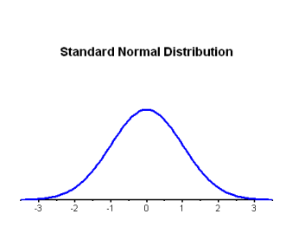

**Example #10**

Use Table A to find the proportion of observations from the standard Normal Distribution that satisfies each of the following statements. In each case, sketch a standard normal curve and shade the area under the curve that is the answer to the question.

1. Greater than z = 1.53

b) Between -0.58 and 1.79

c) In a standard Normal distribution, 20% of the observations are above what value?

**Example #11**

In the 2008 Wimbledon tennis tournament, Rafael Nadal averaged 115 miles per hour in his first serves. Assume that the distribution of his first-serve speeds is Normal with a mean of 115 mph and a standard deviation of 6 mph. About what proportion of his first serves would you expect to exceed 120 mph? Follow the four step process.

**Example #12**

The heights of three-year-old females are approximately Normally distributed with a mean of 94.5 cm and a standard deviation of 4 cm. What is the third quartile if this distribution. Follow the four step process

**\*\*\*\*Common errors****:**

* 1. Do not “calculator speak” on the test. To get full credit, students should include a sketch of the Normal curve with the mean and standard deviation clearly identified.

**Assessing Normality**

* If the graph of the data is clearly skewed, has multiple peaks, or isn’t bell shaped, that’s evidence that the distribution is not Normal
* However, just because a plot of the data looks Normal, we can’t say that the distribution is Normal
  + 68-95-99 rule can give additional evidence in favor of or against Normality
  + A Normal probability plot also provides a good assessment of whether a data set follows a Normal distribution
    - When examining a Normal probability plot, look for shapes that show clear departures from Normality. Don’t overreact to minor wiggles in the plot.
    - If the points lie close to a straight line, the plot indicates that the data are Normal. Systematic deviations from a straight line indicate a non-Normal distribution.
    - Will not be tested in Normal plots on the AP exam; however, students are welcome to use them

**Making a Normal probability plot:**

1. Arrange the observed data values from smallest to largest and record the percentile corresponding to each data value
2. Use the standard Normal distribution to find the z-scores at these percentiles
3. Plot each observation x against the corresponding z
   1. Put the x-values on the horizontal axis so that when there are values to the right of what we expect, we know the distribution is skewed to the right
4. If all the points on the Normal probability plot suddenly fell down to the horizontal axis, the result would be a dotplot of the data

**Example #13**

The measurements listed below describe the usable capacity (in cubic feet) of a sample of 36 side-by-side refrigerators (*Consumer Reports, May 2010)* Are the data close to Normal? Use the graphing calculator to create a histogram and Normal Probability Plot.

|  |  |  |  |  |  |  |  |  |  |  |  |
| --- | --- | --- | --- | --- | --- | --- | --- | --- | --- | --- | --- |
| 12.9 | 13.7 | 14.1 | 14.2 | 14.5 | 14.5 | 14.6 | 14.7 | 15.1 | 15.2 | 15.3 | 15.3 |
| 15.3 | 15.3 | 15.5 | 15.6 | 15.6 | 15.8 | 16.0 | 16.0 | 16.2 | 16.2 | 16.3 | 16.4 |
| 16.5 | 16.6 | 16.6 | 16.6 | 16.8 | 17.0 | 17.0 | 17.2 | 17.4 | 17.4 | 17.9 | 18.4 |

**Example #14**

The histogram and Normal probability plot below display the land areas for the 50 states. Is this distribution approximately Normal?





Both the histogram and the Normal probability plot indicate that this distribution is strongly skewed to the right. In particular, there is one state whose area is much larger than we would expect if the distribution was approximately Normal. What state is this?